**Team # - Hotel Wizard**

**ITSC 3155 Final Project Report**

**Prepared by: Brevory Foster, Calvin Hathcock, Christine Chee, Sijian Wu**

**Date: 2021/05/02**

**Table of Contents**

1.1 Product Vision 3

1.3 Project Scope and Objectives 3

1.4 Ethical concerns 3

**2 Project Resources** **3**

2.1 Group Members 3

2.2 Data 3

2.3 Hardware and Software Resources 3

2.4 Special Resources 3

**3 Plan** **3**

3.1 Timeline Chart 3

3.2 Task/Milestone Descriptions 4

3.3 2.3 Resource Table 4

**4 System Design** **4**

4.1 Use Case Diagram 4

4.2 DFD diagram 4

4.3 User Stories 4

4.4 Feature List 4

4.5 Storyboard 4

**5 User Tests** **4**

5.1 Test procedure 4

5.2 User Test and Results 4

5.3 Conclusion 5

**6 Lessons Learned** **5**

**7 Future work** **5**

**8 Appendices** **5**

8.1 Sketches 5

8.2 Software Repository 5

1 Introduction

The idea of targeting our data visualization project on hotels and resort owners was from reflecting back on the struggles we have as customers booking hotel rooms. From there, we asked each other when was the best time to book a hotel room? How long do people usually book their rooms for? We thought about the owners and or managers perspective on how they maintain profits when there aren't a lot of bookings. For example during the times of the year when a lot of families and students are still in class and are not looking to travel out of town.

As a hotel and or resort owner, you would want to efficiently maintain its services from managing the front desk, cleaning, dinner, and etc. You want to hire enough people to manage an establishment and also enough to where you are maximizing labor and labor costs. Thus, we came up with an idea of gathering data that displays when a hotel and resort have the highest and lowest amount of bookings.

## 1.1 Product Vision

Hotel and resort owners will be the target of the data visualization. They will be able to use our product to determine the amount of labor needed during the different seasons of the year. PRODUCT NAME is a business management application. They will be able to optimize their workers schedules along with

optimizing their finances for who they should hire. Hotel and resort owners would want to use this product because they want to be able to know when and where to invest their money. Unlike our competitors like getting, our product will optimize labor on a season by season basis. This product will allow hotels and resorts to always be prepared no matter what time of the year it is.

1.2 Customer Description

The customers for this visualization is aimed towards hotel and resorts owners mainly as they will be the ones to oversee the establishment. However we are also aiming for people that are in charge of hiring the labor that runs their establishment and the people in charge of managing the establishment's finances.

## 1.3 Project Scope and Objectives

This product will be geared towards hotel and resort owners only as the data is relevant to those who manage and run room booking services. The product will be able to display data of busiest times of the year for booking, booking group sizes, duration of stay, and etc. The product will also provide a calculator that will assist in hotel budget calculations.

In scope of Hotel Wizard:

* Develop visuals (Graphs and/or charts) for Hotel data
* Develop a calculator for hotel budget calculation and estimates regarding labor needed

## 1.4 Ethical concerns

Ethical Concerns for this product is its reliability to work for every hotel or resort and possible labor issues as it is developed for maximizing labor costs.

# 2 Project Resources

## 2.1 Group Members

1. Brevory Foster

2.Calvin Hathcock

3.Christine Chee

4.Sijian Wu

## 2.2 Data

Data Source: https://www.kaggle.com/jessemostipak/hotel-booking-demand

The data we chose is a .csv (comma separated values) file. It contains various information about two hotels. A city hotel and a resort hotel. It includes information about specific times of the year that individual customers booked and the different details about their stay such as if they brought children, what country they are from, if they’re a repeat customer, reservation status and more. We think this data will be perfect for analyzing rates of travel at different points in the year and even creating a predictive model for upcoming years.

## 2.3 Hardware and Software Resources

Our project is a Python based web application that used libraries such as plotly, dash, and pandas. We built diagrams using draw.io and the microsoft office suite.

The whole project was built on our local PC’s.

## 2.4 Special Resources

We did not use special resources for this project.

# 3 Plan

This section contains is a list of tasks and deliverables associated with the project, a Gantt chart

depicting task durations, dependencies and completion dates, and a summary of resource

requirements and assignments for each task.

## **3.1** Timeline Chart

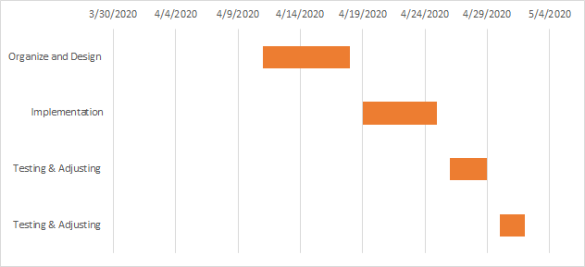

*Figure 1. Gantt Chart*

|  |  |  |  |
| --- | --- | --- | --- |
| **Task** | **Start Date** | **End Date** | **Duration** |
| Organize and Design | 4/11/2020 | 4/18/2020 | 7 |
| Implementation | 4/19/2020 | 4/25/2020 | 6 |
| Testing & Adjusting | 4/26/2020 | 4/29/2020 | 3 |
| Testing & Adjusting | 4/30/2020 | 5/2/2020 | 2 |

## **3.2** Task/Milestone Descriptions

**Milestone 1 - Organizing and Design**

Milestone one is where we brainstorm ideas for the project. Here we plan out a rough draft of what we expect our product to look like and its features. We had planned for our product to be geared towards hotel owners as our charts and graph will be displaying hotel customer booking data. We would also like to implement a calculator that would assist hotel owners calculate their own hotel budget in hope it can maximize costs and gains.

**Milestone 2 - Implementation**

Milestone 2 is where our team begins to code and implement our charts and graphs. Including our calculator feature.

**Milestone 3 - Testing and Adjusting**

At milestone 3, after the charts and our calculator has been coded and implemented, we begin to test and see how well it performs. While also beginning to document our procedure and begin to type out our repost.

**Milestone 4 - Testing and Adjusting**

Milestone 4, is more of finalizing our work. At this point there shouldn't be much testing left other than smoothing out rough edges.

## 3.3 2.3 Resource Table

|  |  |
| --- | --- |
| **Task** | **People** |
| Team Manager, Contributor | Brevory Foster |
| Contributor, Coding and Implementation | Calvin Hathcock |
| Contributor, Documentation | Christine Chee |
| Contributor | Sujian Wu |

|  |  |
| --- | --- |
| **Task** | **People** |
| 1. Introduction | Christine Chee |
| 1.1 Product Vision | Brevory Foster |
| 1.3 Project Scope and Objectives | Christine Chee |
| 1.4 Ethical Concerns | Christine Chee |
| 2.2 Data | Calvin Hathcock |
| 2.3 Hardware and Software Resources | Calvin Hathcock |
| 2.4 Special Resources | Brevory Foster, Calvin Hathcock, Christine Chee, Sijian Wu |
| 3.1 Timeline Chart | Brevory Foster |
| 3.2 Task/Milestone Descriptions | Brevory Foster, Christine Chee |
| 4.1 Use Case Diagram | Sujian Wu |
| 4.2 DFD Diagram | Calvin Hathcock |
| 4.3 User Stories | Christine Chee |
| 4.4 Feature List | Calvin Hathcock |
| 4.5 Storyboard | Christine Chee |
| 5.1 Test Procedure | Brevory Foster |
| 5.2 User Test and Results | Brevory Foster |
| 5.3 Conclusion | Brevory Foster |
| 6. Lessons Learned | Brevory Foster, Calvin Hathcock, Christine Chee, Sijian Wu |
| 7. Future Work | Brevory Foster |
| 8. Appendices | Brevory Foster, Calvin Hathcock, Christine Chee, Sijian Wu |

# 4 System Design

## 4.1 Use Case Diagram

*Figure 2. Hotel Wizard Use Case Diagram*

## 4.2 DFD diagram

Hotel Wizard DFD

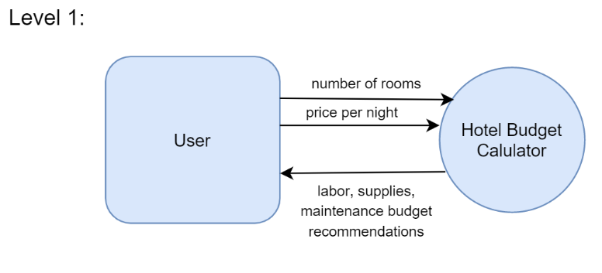

*Figure 3.*

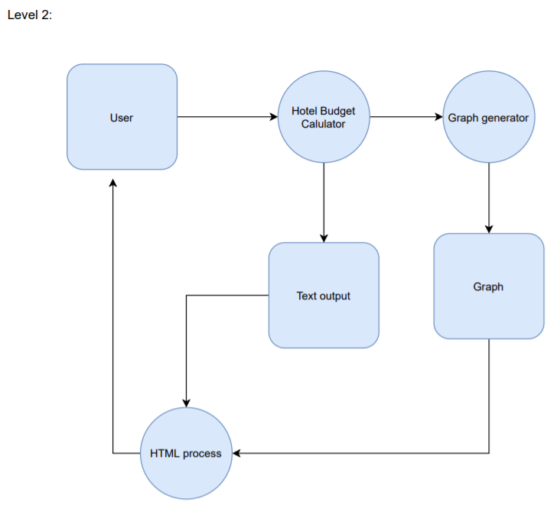

*Figure 4.*

## 4.3 User Stories

**User Stories:**

* As a user I want to be able to determine the busiest times of the year
* As a user I want to be able to calculate hotel expenses
* As a user I want to use visual to help me visualize the yearly prospects
* As a user I want to be able to use application to help maximize budget and labor costs

## 4.4 Feature List

**Feature 1: Visual Graphics**

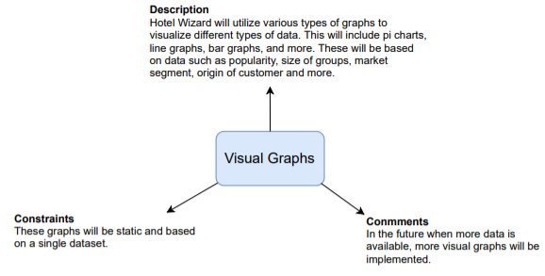

*Figure 5. Hotel Wizard Feature 1, Visual Graphics*

**Feature 2: Budget Calculator**

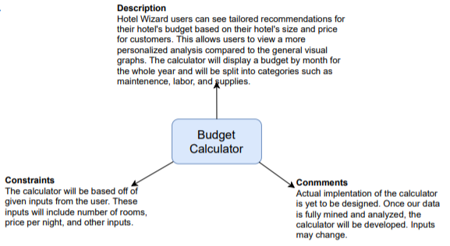

*Figure 6. Hotel Wizard Feature 2, Budget Calculator*

## 4.5 Storyboard

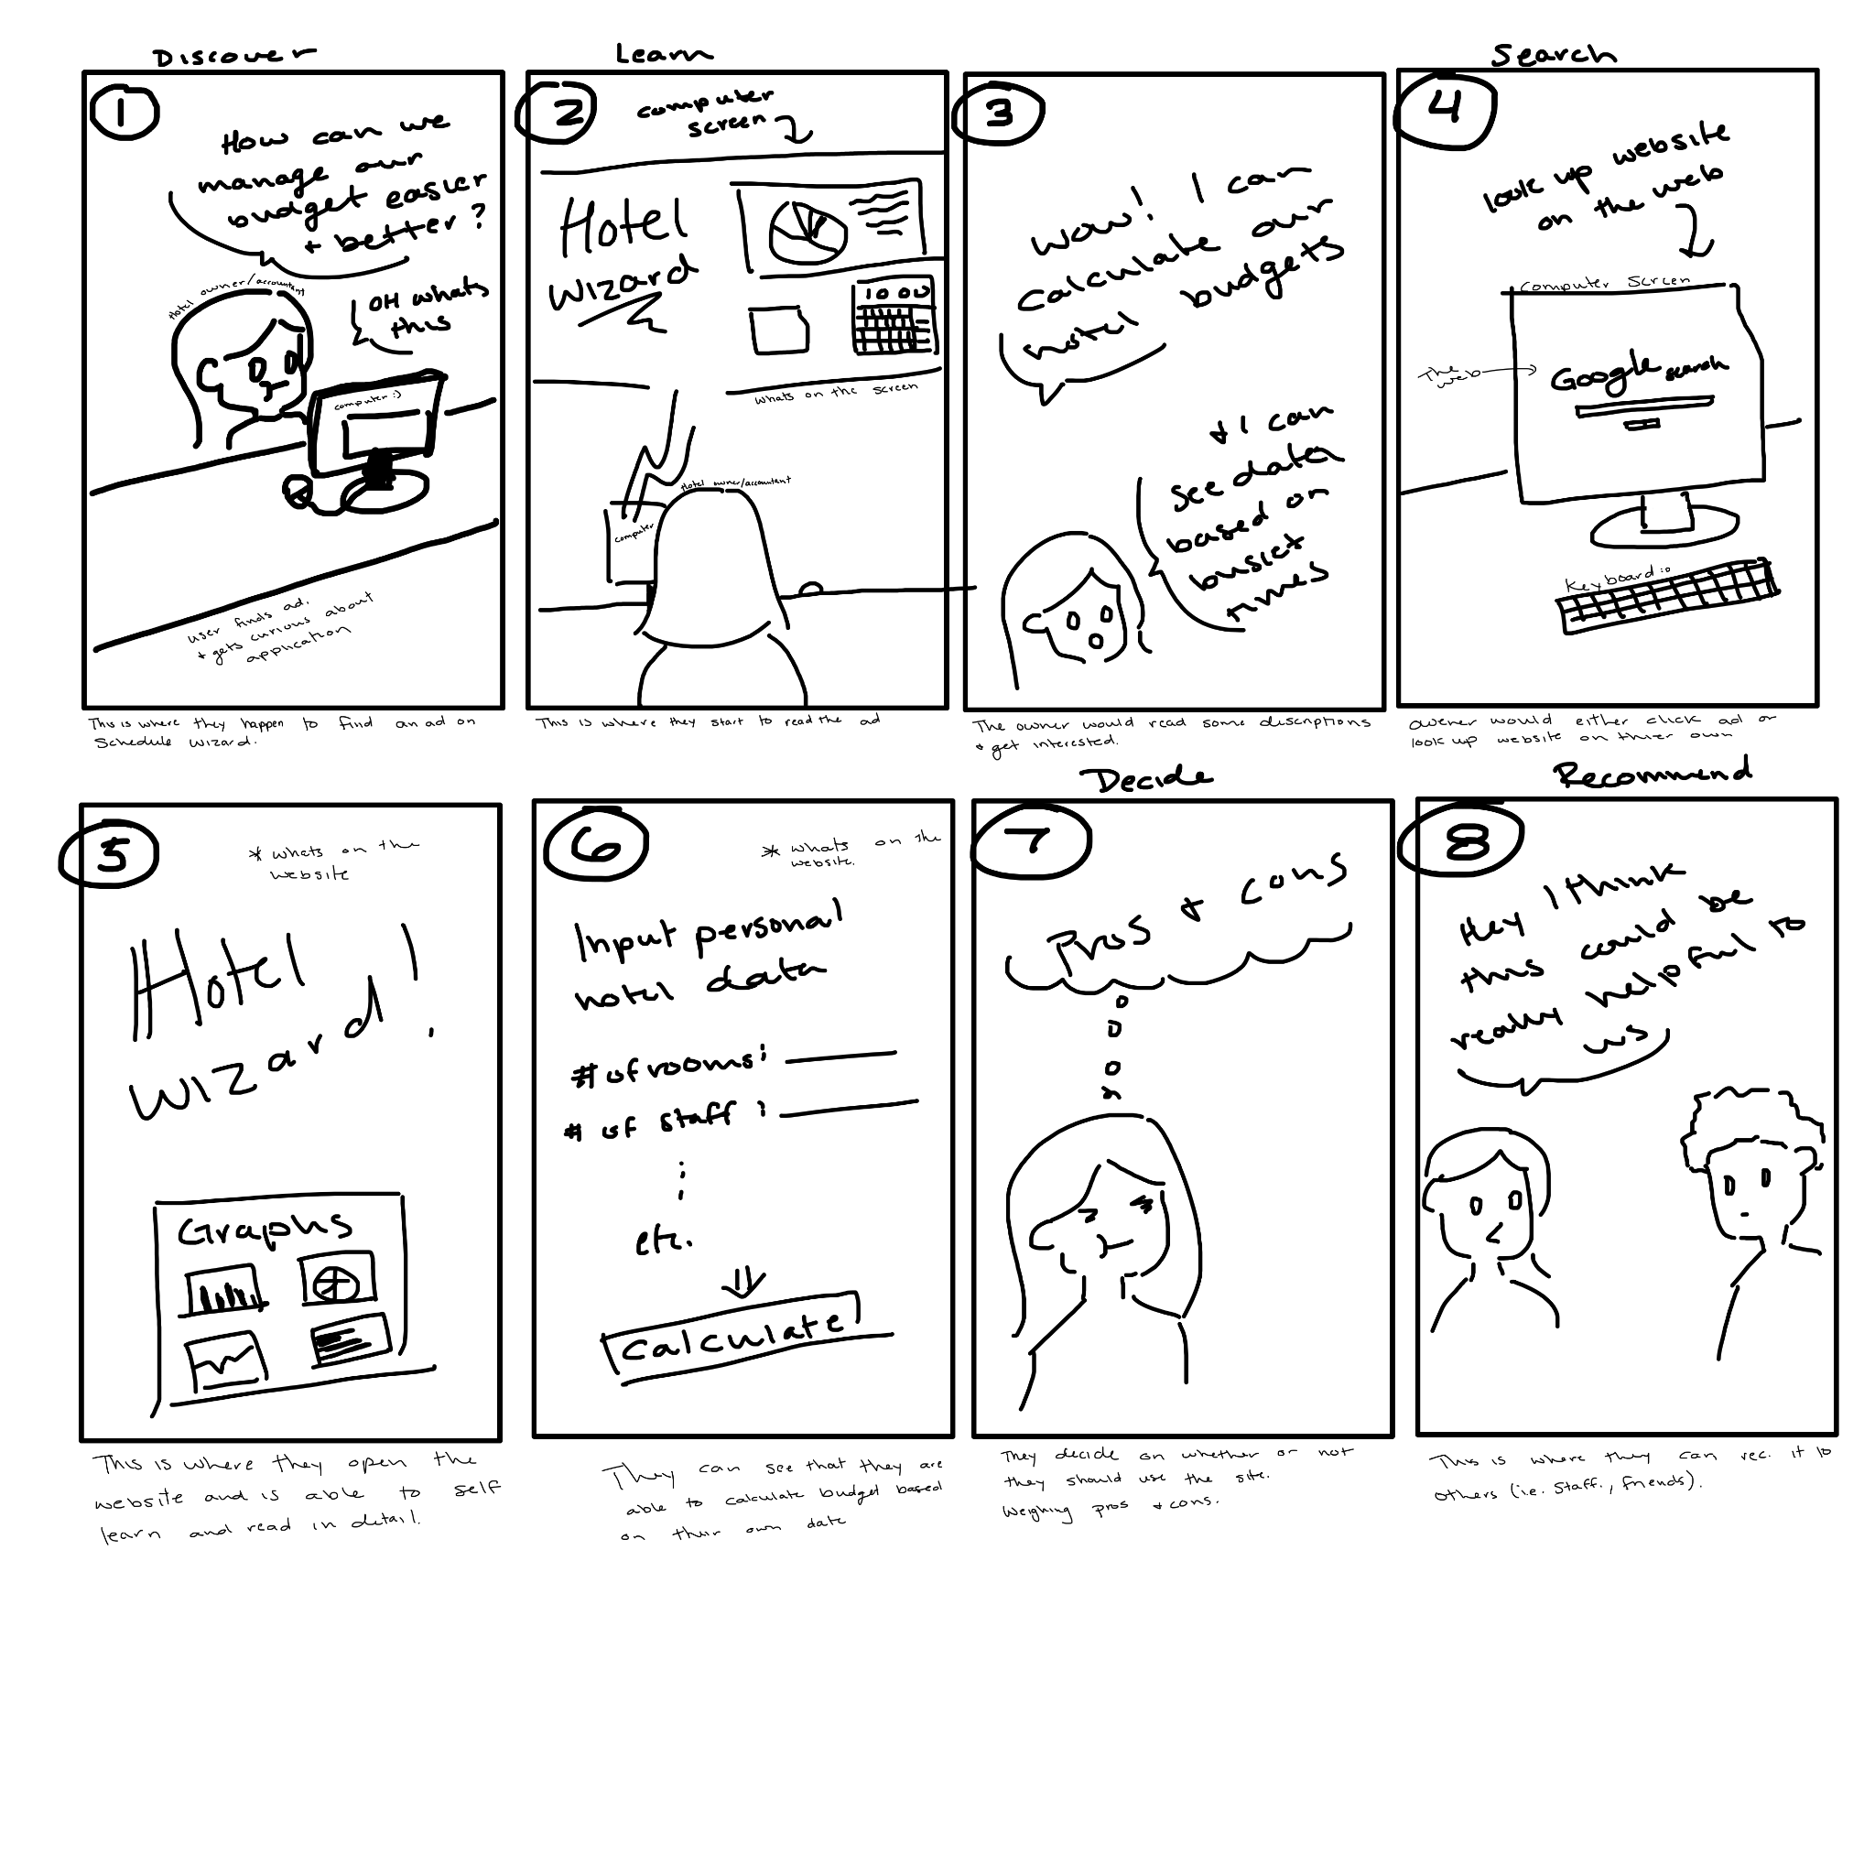

*Figure 7. Hotel Wizard Storyboard*

# 5 User Tests

## 5.1 Test procedure

Our paired team tested our application based on 4 user stories that covered the basic functionality that we wanted and did implement.

1. As a Hotel Owner you want to find which country the majority of your guests are going to come from.
2. As a Resort Owner looking to build more rooms for guests, you want to know what percentage of reservations have 4 or more people.
3. As a Hotel Owner you want to be able to find out how likely is it that people booking 30 days in advance will cancel their order
4. As a hotel owner you want to know how much money you need to be spending each month on your hotel and plan your budget accordingly

## 5.2 User Test and Results

1. They did very well on the first test, but we did notice they couldn't find the name of the country because they were all abbreviations, but they could quickly point out which country it was
2. This was a bit trickier for them because at the time the legend had no label and they kind of skimmed over the introduction at the top which people will do and the charts did not have the value of what was being measured only the number
3. They did pretty bad on this mostly because of their lack of understandings of how histograms work they couldn't locate anything
4. They did great with this one. Super intuitive.

## 5.3 Conclusion

Out of the 4 tests the users did well on two of them and struggled on the other two. The first and fourth were very intuitive and it did not take long for them to understand the functionality, but the second and third tests were not as easy for them mainly because they were not getting enough information on how to make sense of the data. We adjusted this in our final version by using a python library that stores country names and abbreviations and just swapping out all the values. To fix the second test’s problems we added a title for the legend and showed what was being measured in each slice of the pi chart. For the histogram we just added more explanatory text at the top for the user to go to to understand how to read a histogram.

# 6 Lessons Learned

The biggest takeaway from completing this project was how important it is to properly design, engineer, and test your software before jumping into implementation. Without the proper foundation of system design, you’re shooting yourself in the foot when it comes to making software. The importance of organization and time management was hugely apparent, without it, we would have been a mess.

# 7 Future work

In the future we could definitely add another calculator that takes in a month from a hotel and some other other logistic questions about their hotel and gives an estimated inflated or deflated room price for that particular month based on the inputs and demand. We would also like to expand Hotel Wizard beyond just statistical data and become a platform for market research, reviews, and more.

# 8 Appendices

<https://www.kaggle.com/jessemostipak/hotel-booking-demand>

https://plotly.com/python/

## 8.1 Sketches

*Figure 8. Sketches*

## 8.2 Software Repository

<https://github.com/3155SP202110/TeamRepository>

8.3 WBS tool

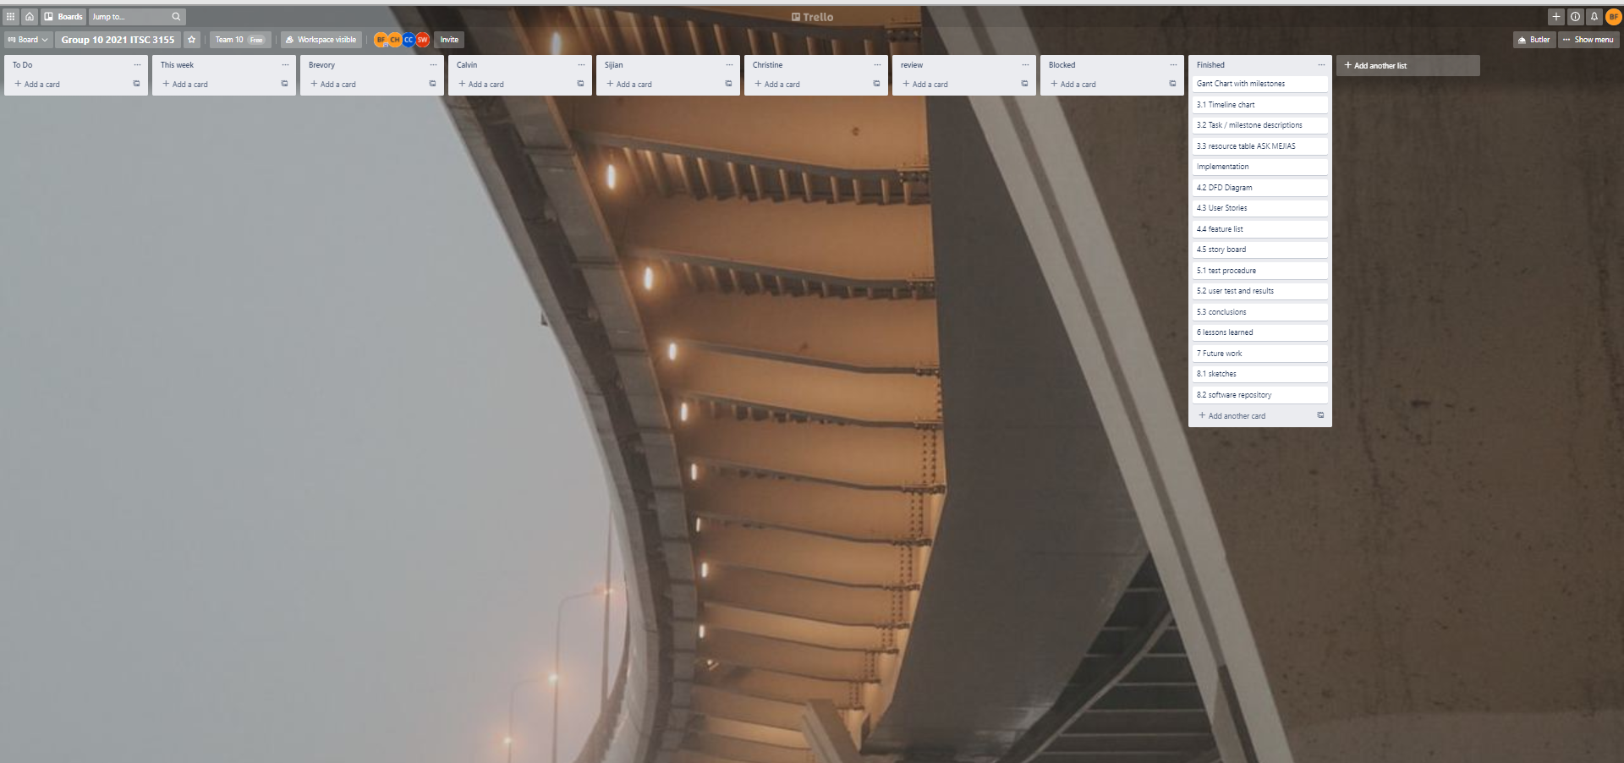

*Figure 9. Team Trello Board*